Reflective Summary

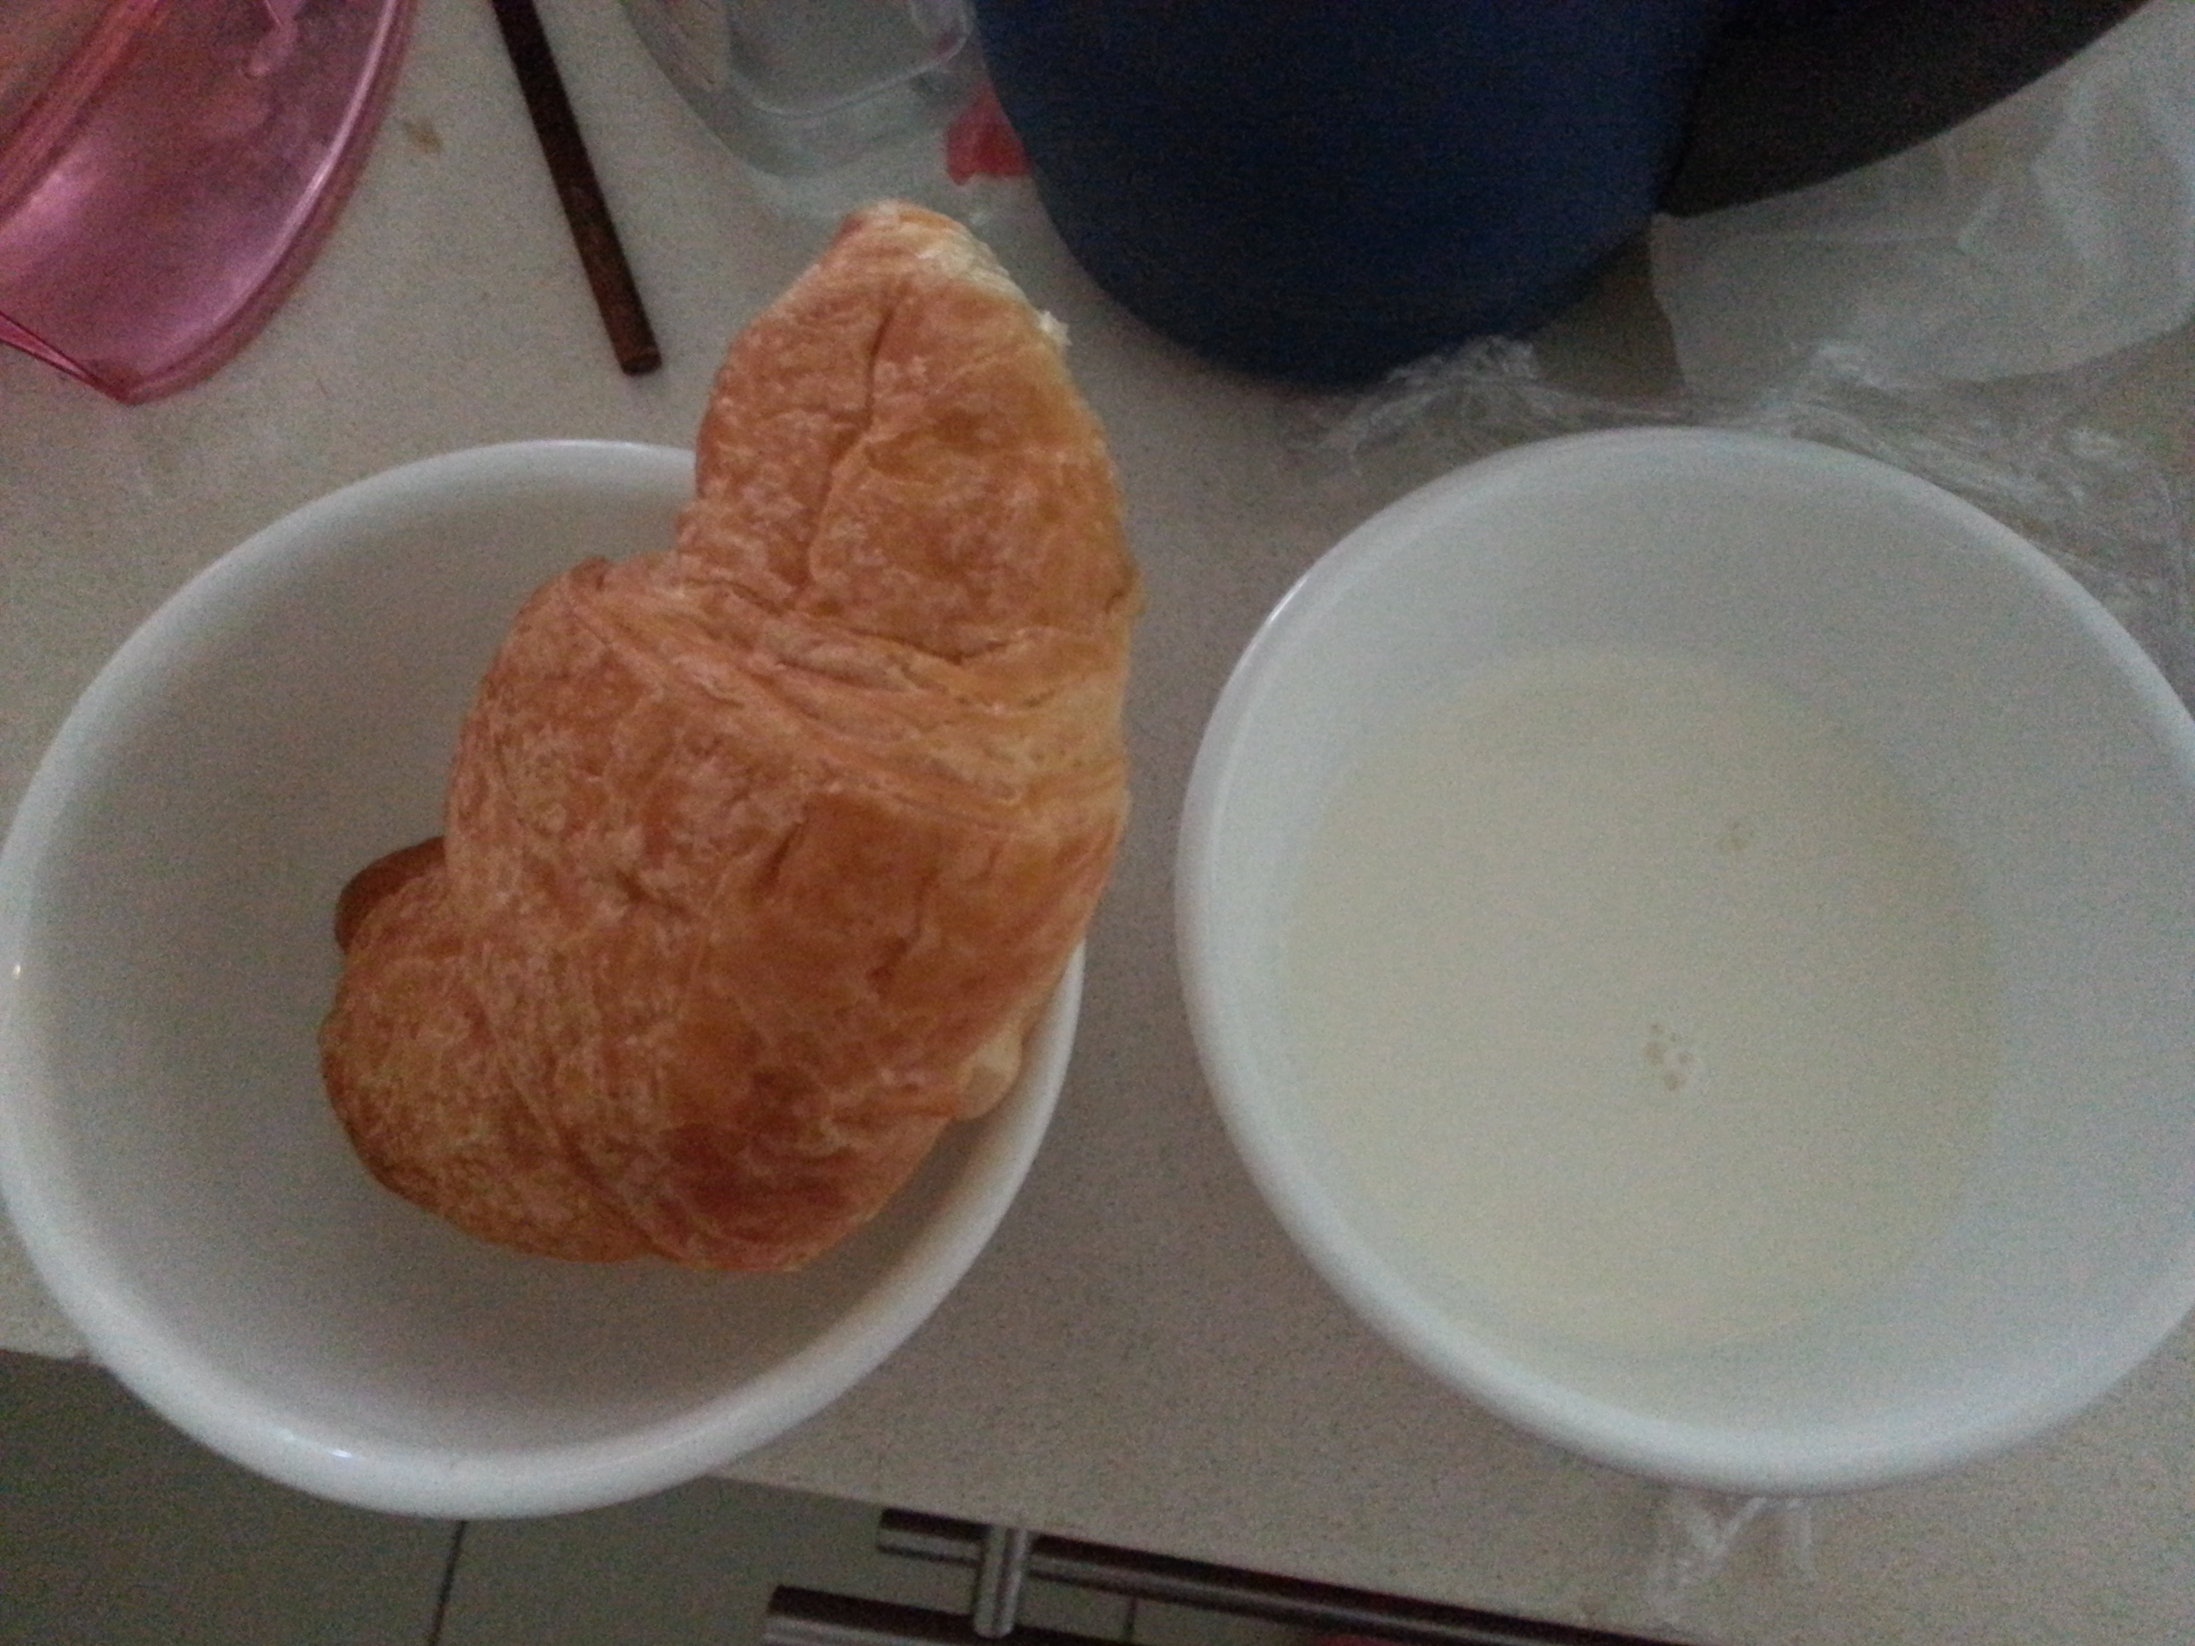

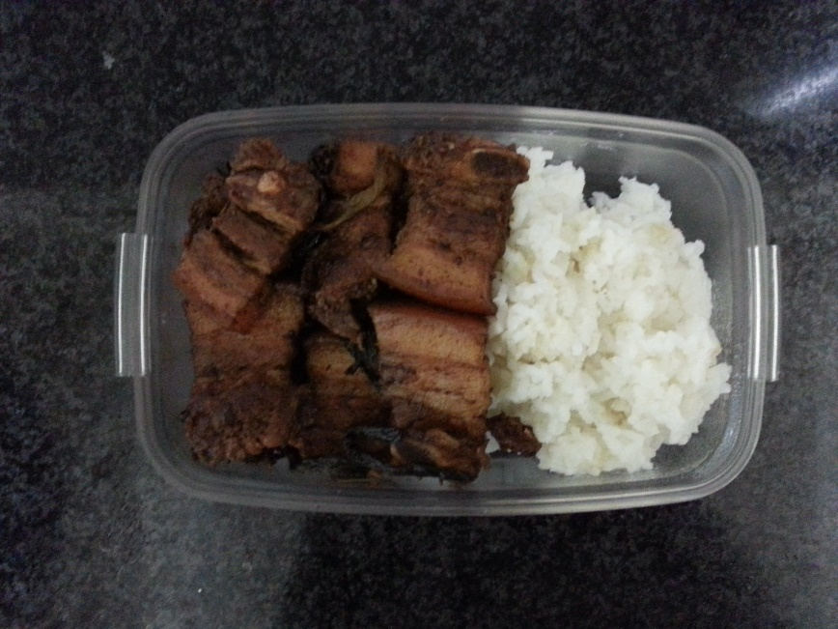

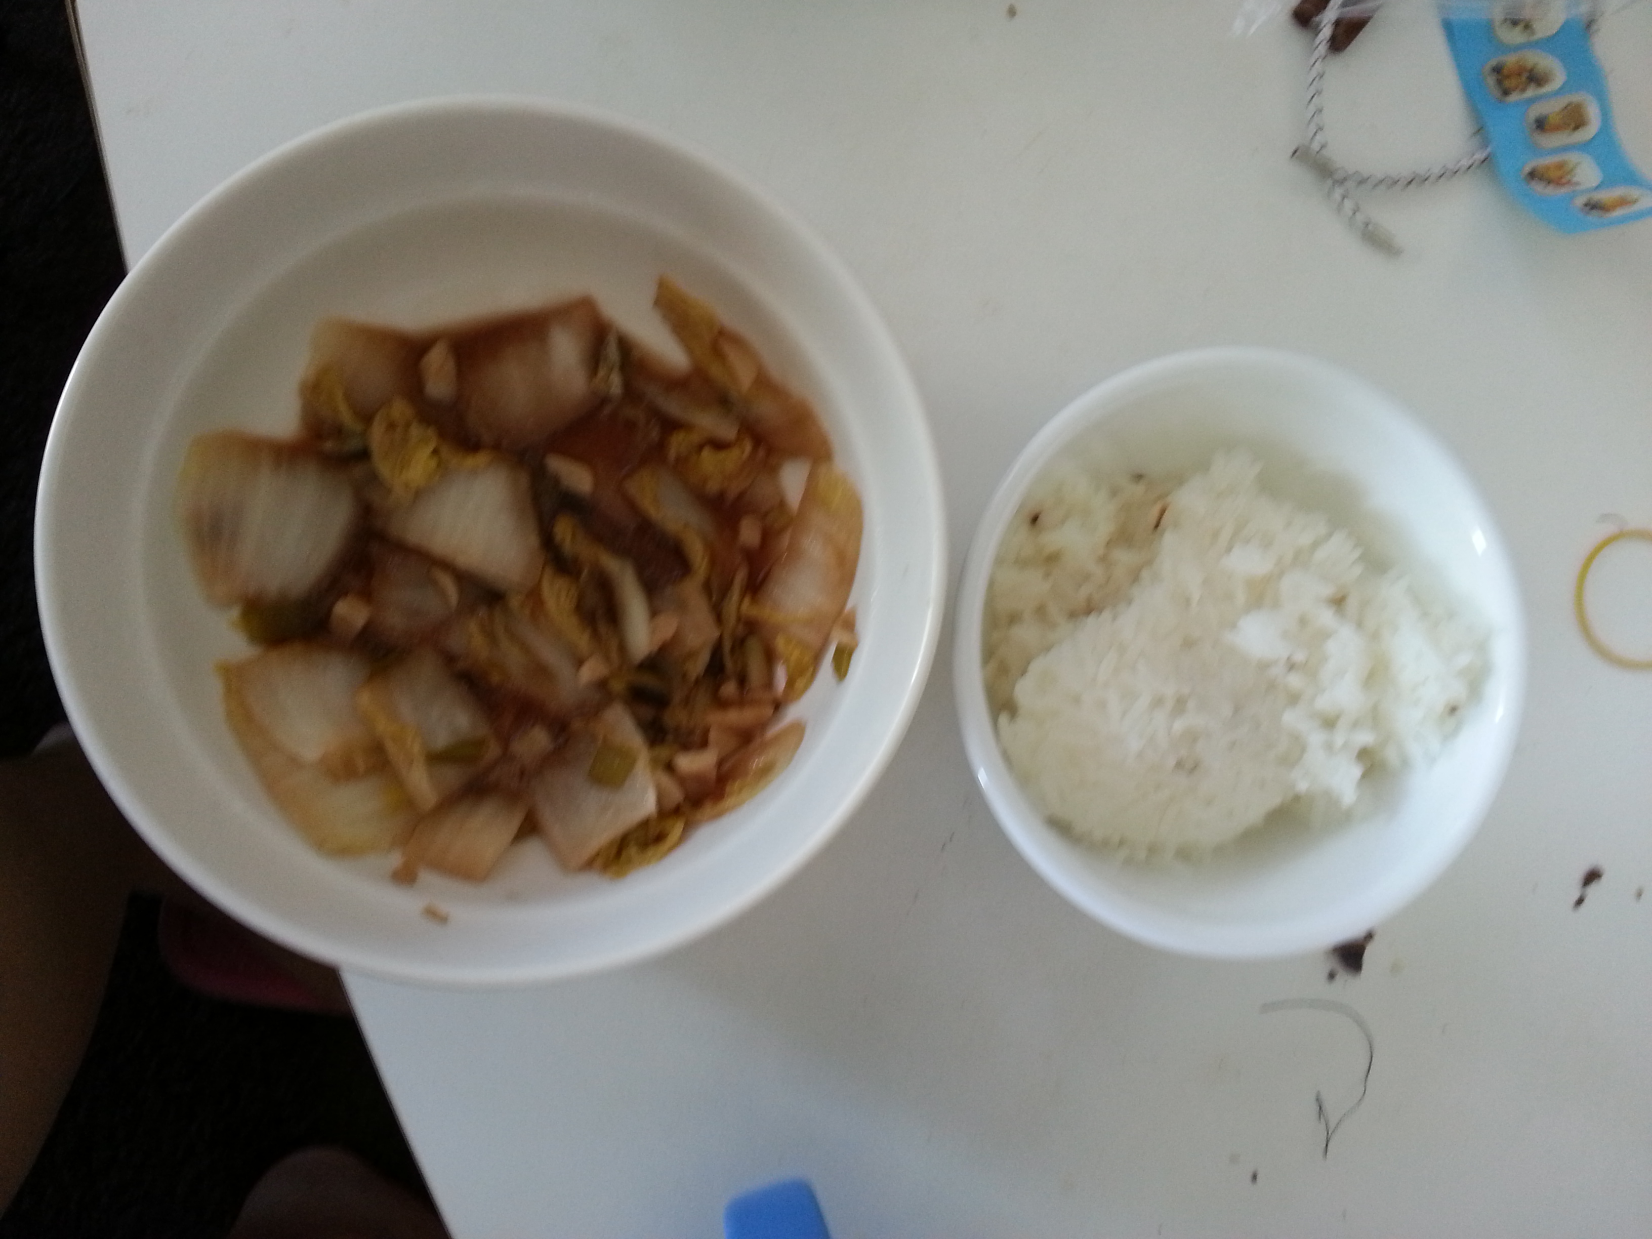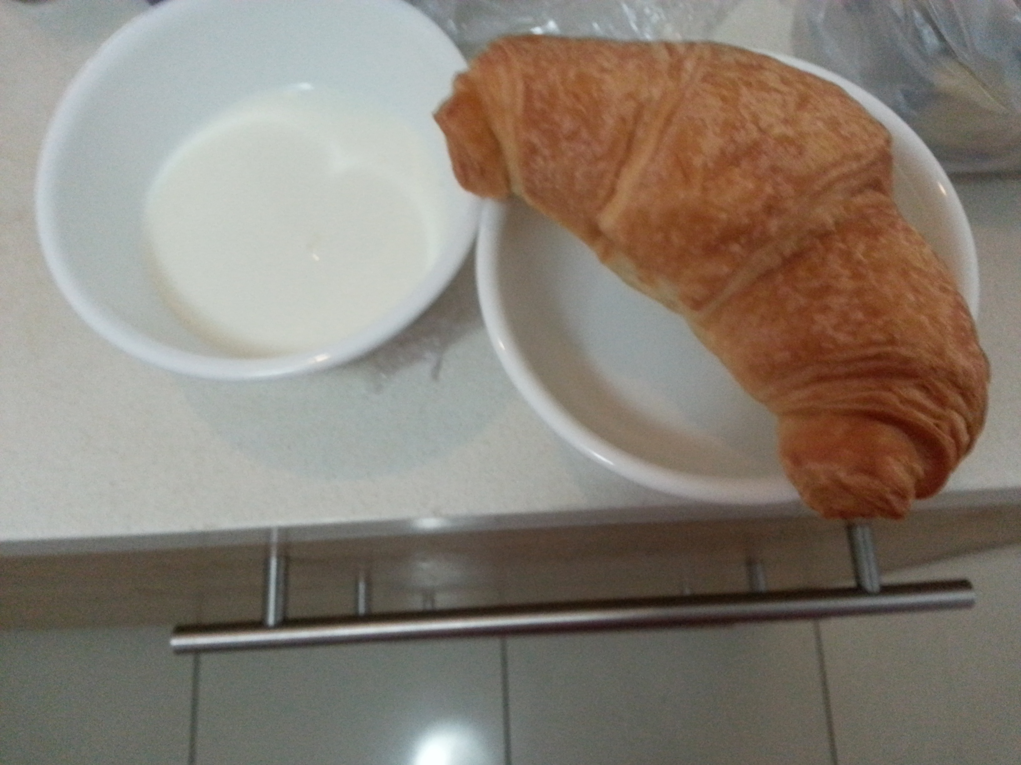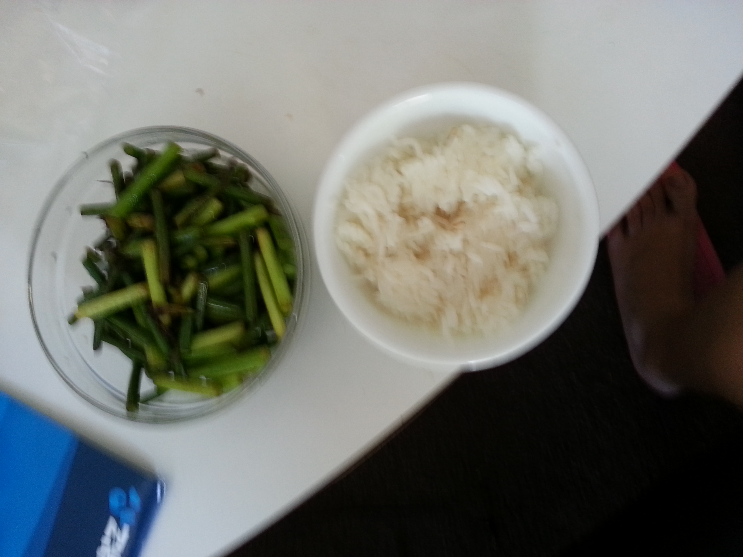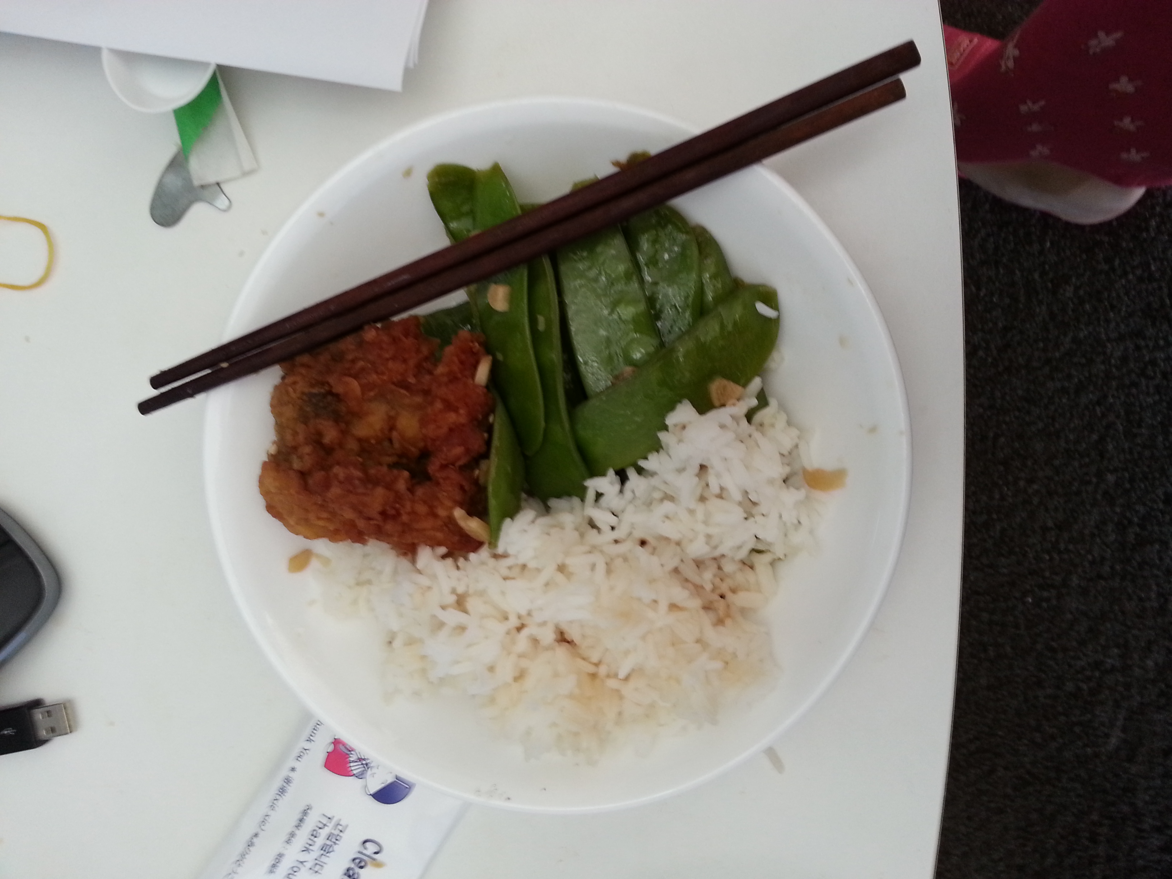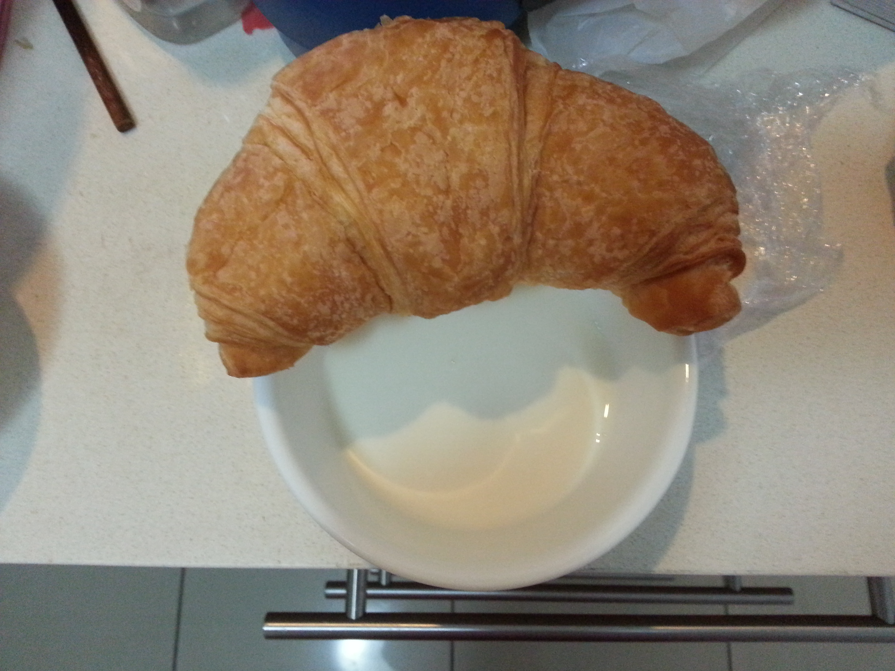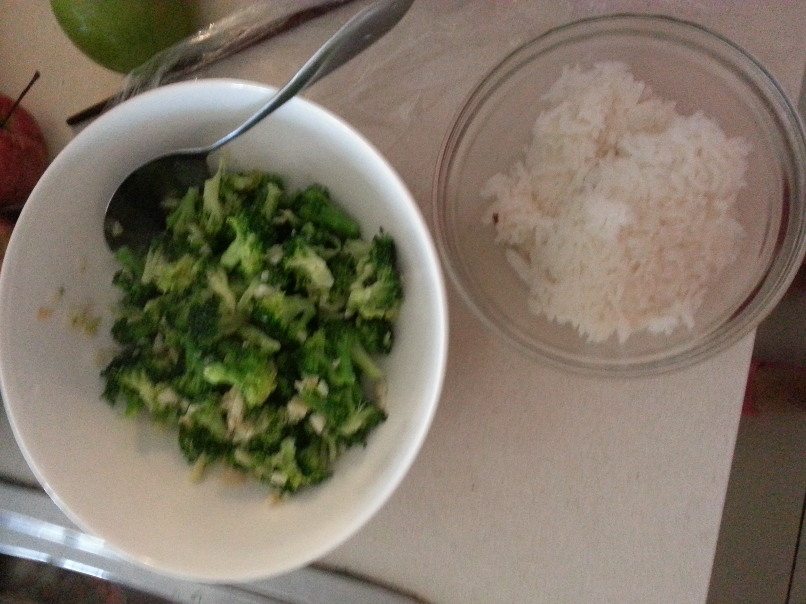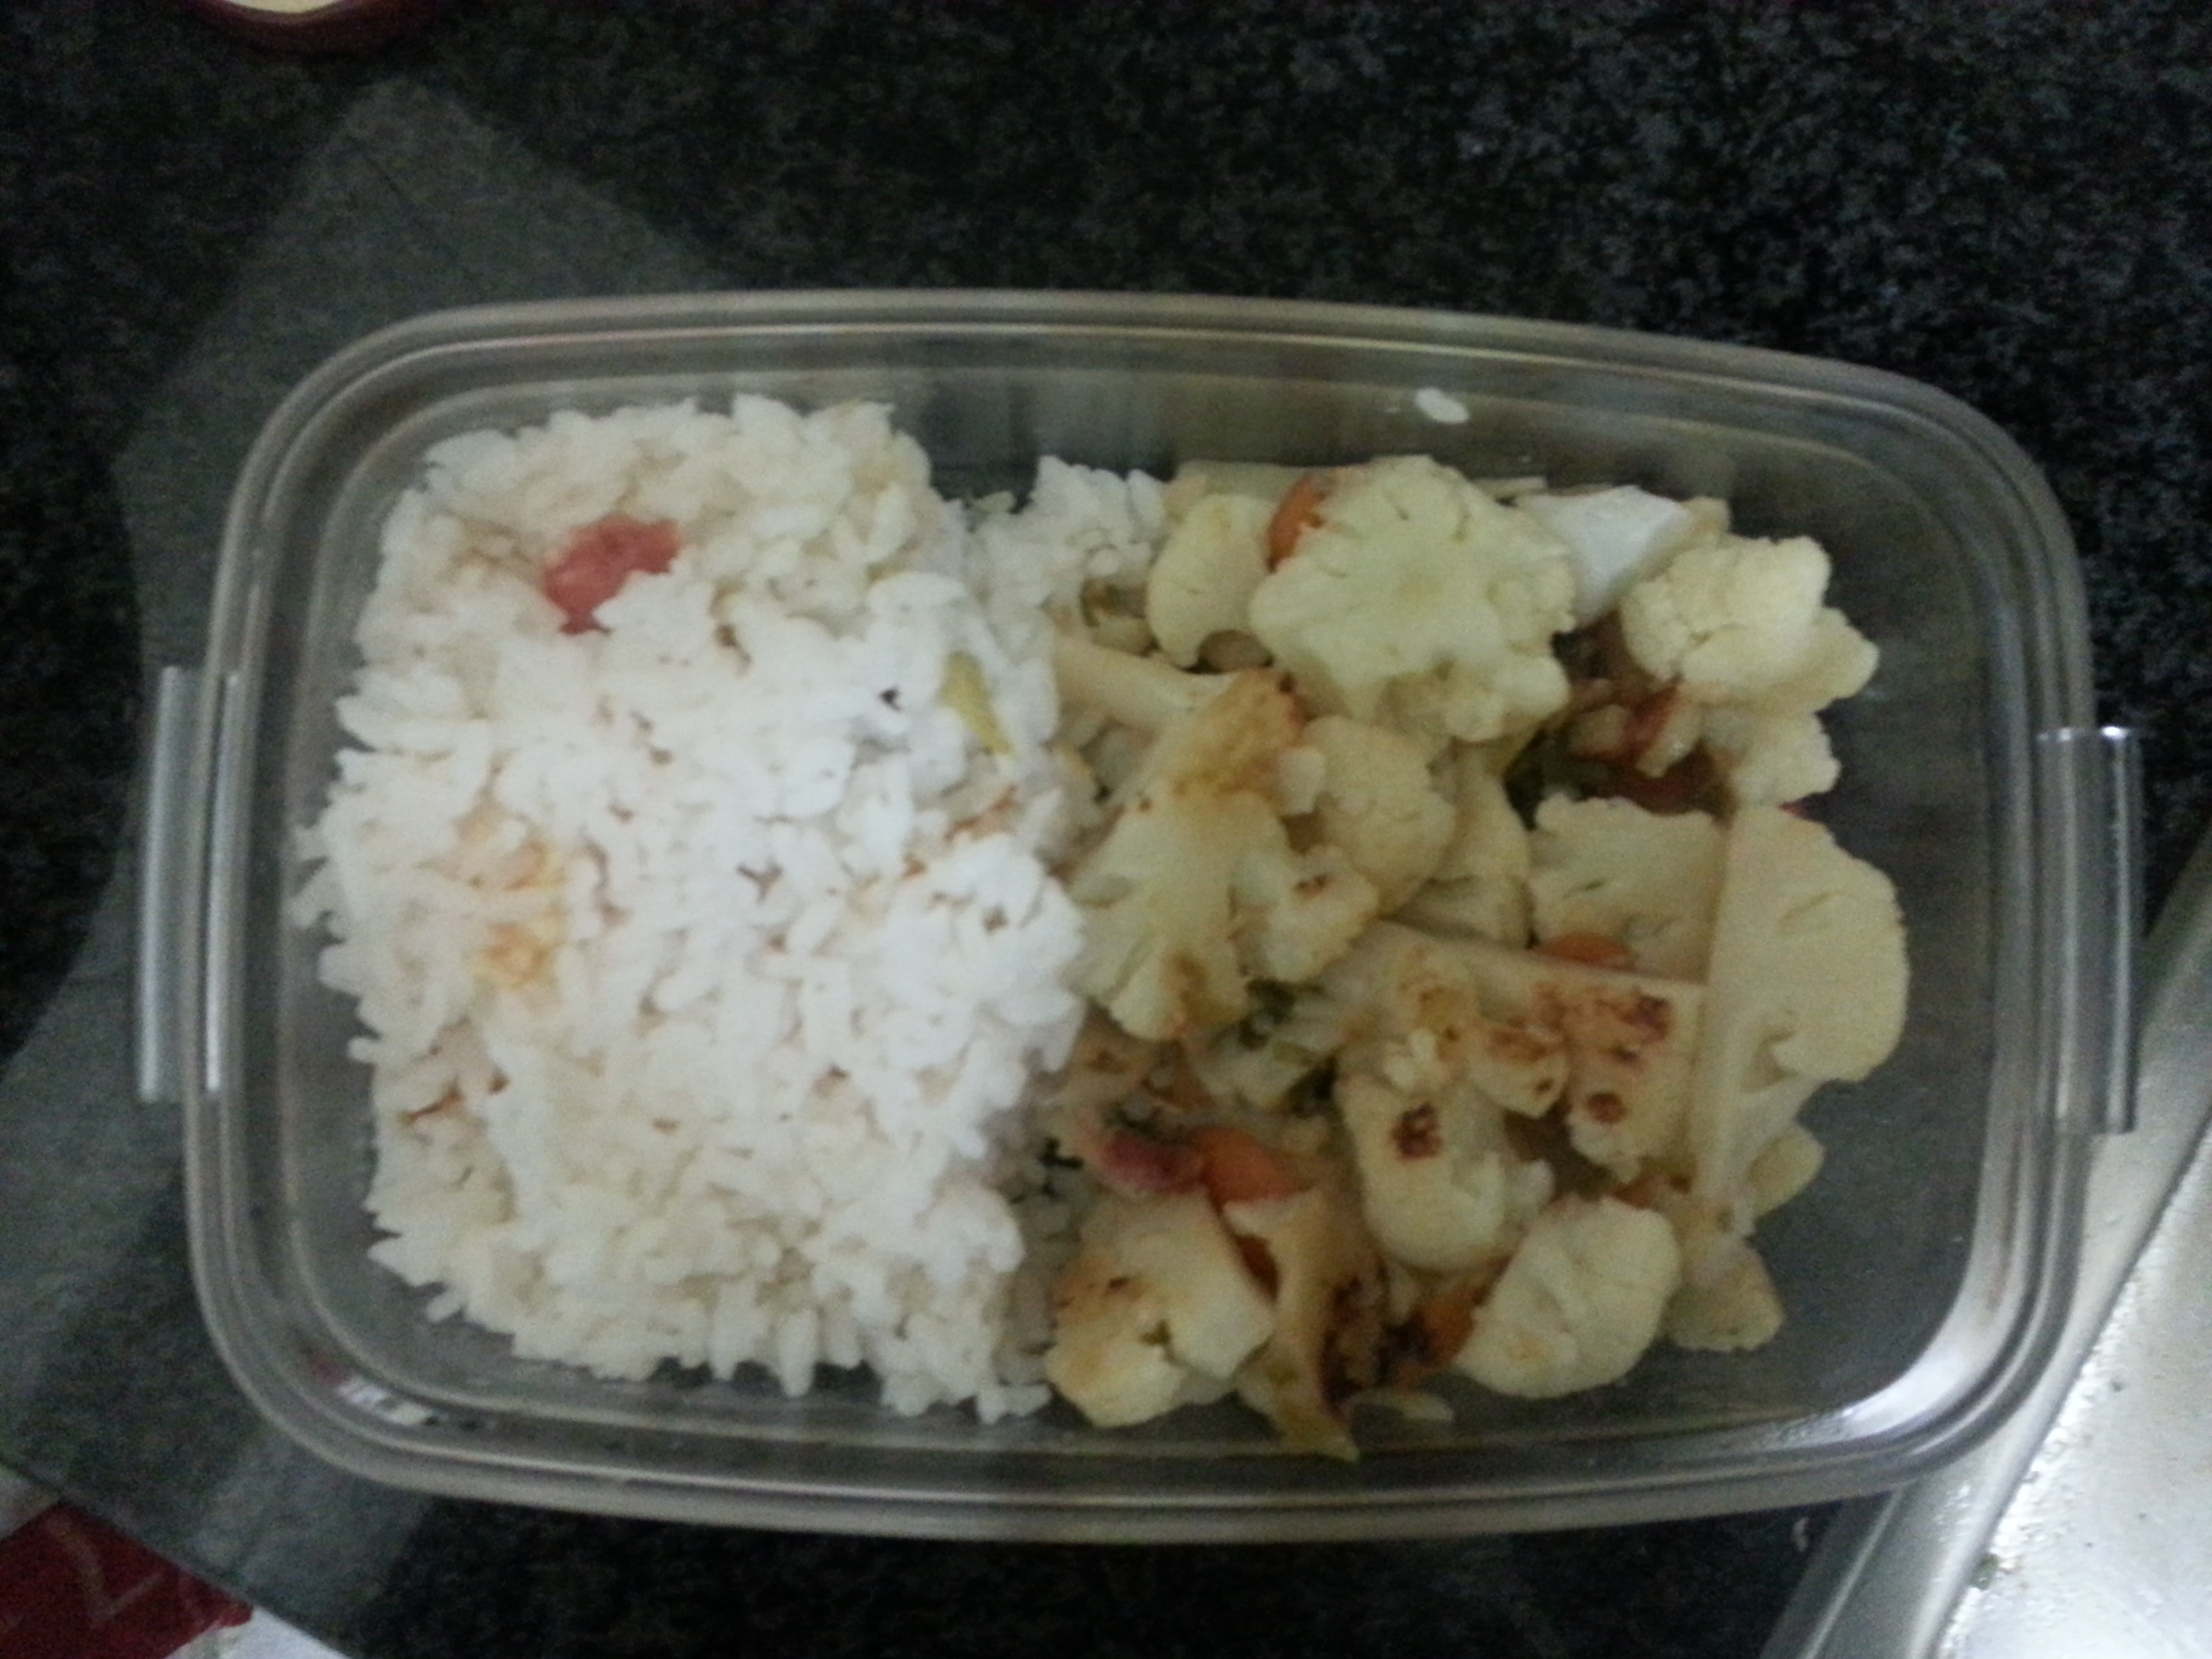

Logging daily food by photograph is not very convenient for me. It is because I always forget to take photos on my meal before I started eating.

Besides, owing to the fact that the meal time is not always fixed, so I cannot set an alarm to remind myself. The second problem is the picture itself cannot provide any information except from what I ate. For example, the amount of food cannot be effectively presented by pictures.

Another problem is that keep taking photos will result in the shortage of storage in my phone.